Administration Post 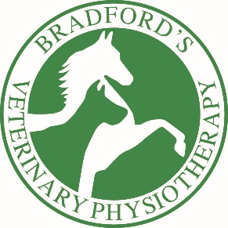
We are a small team of Chartered Physiotherapists who specialise in both Veterinary Physiotherapy and Human Physiotherapy services. We treat mainly horses however we have growing canine and human services alongside. We are a team of 5 individuals looking to grow and develop our services offering high end personalised treatments to our clients based widely across the mid-west region and beyond.
We are looking for an enthusiastic, thorough and conscientious person to join our office team to assist in office duties and coordination of services.
Ideally the successful candidate will have good local geographical knowledge, some equine knowledge and have some experience from either the Veterinary sector/Physiotherapy sector however this is definitely not essential.
The role would involve managing Physiotherapists diaries and appointments, liaising with Veterinary practices and associated other paraprofessionals, so clear communication skills and politeness, approachable, professional and a good understanding of confidentiality are a must. The role is also responsible for taking client payments and some invoicing duties.
The candidate would need to have very good computer skills, predominantly Microsoft in all areas and have some awareness and knowledge of social media.
Location is currently office based in Pixley, Ledbury however likely to move to the Malvern Wells area at some point in the forthcoming months/years
21hrs/week across three days Wed/Thurs/Fri. 9-4pm
The role would need flexibility with regards to covering other staff holidays throughout the year so more hours and flexibility would be needed during these times.
Rate of pay depending on experience
Closing Date: 30th July

For all enquiries and applications please contact Rhiannon Bradford
rhiannon@bradfordsvetphysio.co.uk
07791512128
Bradford’s Physiotherapy
Alexander Park, Pixley, Ledbury Herefordshire HR8 2RW

